Autonomous system

🌐 What Is an Autonomous System (AS)?
# Source: Chatgpt (GPT‑5 Mini) at [12/15/2025]
An Autonomous System (AS) is a large network or group of networks under the control of a single organization that shares a common routing policy and appears as a single entity to the outside world when participating in internet routing.

🧠 Simple Definition:
# Source: Chatgpt (GPT‑5 Mini) at [12/15/2025]
An Autonomous System is a collection of IP networks managed by one organization, using one consistent routing strategy, and identified by a unique AS number (ASN).

🌐 What Is ASes?
# Source: Chatgpt (GPT‑5 Mini) at [12/15/2025]
ASes is simply the plural form of AS, which stands for Autonomous System.

🧠 Simple Definition:
# Source: Chatgpt (GPT‑5 Mini) at [12/15/2025]
ASes = Autonomous Systems — individual networks or groups of IP networks that operate under a single administrative authority and share a unified routing policy.

🧭 How ASes Work Together
# Source: Chatgpt (GPT‑5 Mini) at [12/15/2025]
When data travels across the internet, it often crosses multiple ASes:
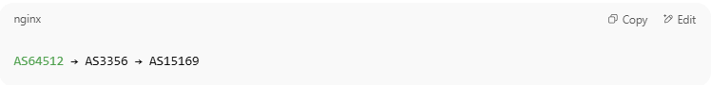AS64512 → AS3356 → AS15169

Each AS:
- Has its own policies
- Controls its own IP prefixes
- Exchanges routes with other ASes using BGP

📦 Real-World Example:
# Source: Chatgpt (GPT‑5 Mini) at [12/15/2025]
- An ISP (Internet Service Provider) like AT&T or Vodafone is an AS.
- A large company like Google, Amazon, or Microsoft may operate multiple ASes for different regions or functions.
- A university network with its own internet gateway can be an AS.

🔢 What Is an ASN (Autonomous System Number)?
# Source: Chatgpt (GPT‑5 Mini) at [12/15/2025]
An ASN is a unique number assigned by a regional internet registry (like ARIN, RIPE, APNIC) that identifies each AS.
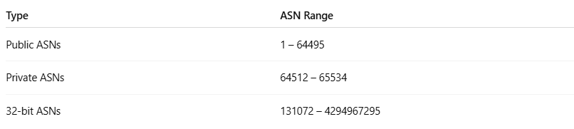
Type | ASN Range
Public ASNs | 1 – 64495
Private ASNs | 64512 – 65534
32-bit ASNs | 131072 – 4294967295

📡 Types of Autonomous Systems
# Source: Chatgpt (GPT‑5 Mini) at [12/15/2025]
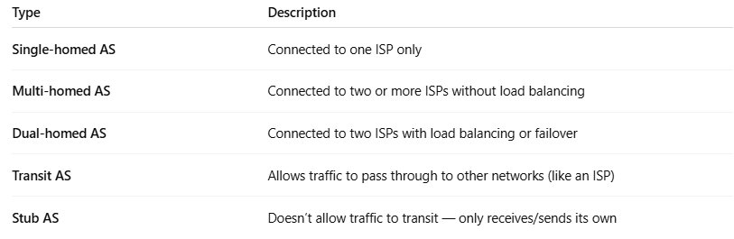
Type | Description
Single-homed AS | Connected to one ISP only
Multi-homed AS | Connected to two or more ISPs without load balancing
Dual-homed AS | Connected to two ISPs with load balancing or failover
Transit AS | Allows traffic to pass through to other networks (like an ISP)
Stub AS | Doesn’t allow traffic to transit — only receives/sends its own

🧭 Role of AS in Routing
# Source: Chatgpt (GPT‑5 Mini) at [12/15/2025]
- BGP (Border Gateway Protocol) is the routing protocol that uses ASNs to decide how data travels across the internet.
- Each AS advertises the IP prefixes it controls to neighbors via BGP.
- Routers make decisions using AS path data (a list of ASNs that a packet has passed through).

📍 Example in BGP
# Source: Chatgpt (GPT‑5 Mini) at [12/15/2025]
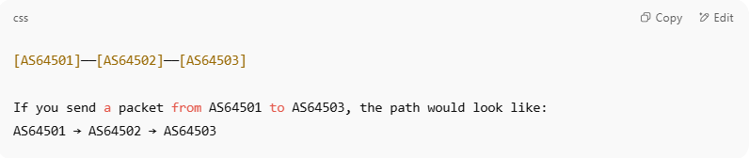
[AS64501]──[AS64502]──[AS64503]

If you send a packet from AS64501 to AS64503, the path would look like:
AS64501 → AS64502 → AS64503

Routers choose the best path by evaluating this AS path and policies.

✅ Summary
# Source: Chatgpt (GPT‑5 Mini) at [12/15/2025]
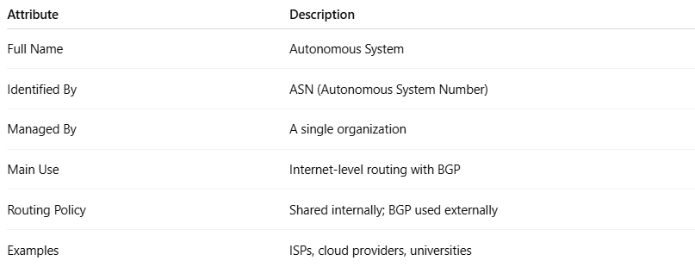
Attribute | Description
Full Name | Autonomous System
Identified By | ASN (Autonomous System Number)
Managed By | A single organization
Main Use | Internet-level routing with BGP
Routing Policy | Shared internally; BGP used externally
Examples | ISPs, cloud providers, universities

